# 

DV Final Project Report

Adithya Guntupalli

U22921880

Table of Contents

Introduction 3

Methodology 3

Analysis 4

Conclusion 10

Bibliography 11

# Introduction

The Player’s Unknown Battle Ground is a highly popularized game in which players are exposed to virtual reality. The immense popularity of the game facilitated several players belonging to different parts of the world to compete with each other for a certain prize amount. The analysis of tournaments played in these games offers valuable insights that can be used to appropriately comprehend other players' performance metrics and identify effective strategies. In this study, Tableau software is used to identify trends and patterns present in the tournament data set, which aims to facilitate better optimization of tournament strategies.

# Methodology

In the course of this study, We integrated data from two independent datasets, Data1.csv and Data2.csv, to create PUBG.csv. We were able to generate a more complete dataset that included information from both sources by merging or joining the data based on a common variable or group of factors. The datasets is sourced from “Kaggle” as it contains a plethora of data sets that are verified and ready to utilize for real-world data science applications. The “.csv format” saved data sets combinedly consists of 31 columns and 1048576 rows, containing several types of attributes like, “DBNOs”, “Assist”, “headshot kills” and many other attributes. In addition to that the data set contains information about the types of weapons utilized by the players during the matches. In the course of choosing the data set the initial task performed is surfing the Kaggle site for the appropriate datasets that is capable to address certain queries. The first criterion is the datasets needs to contain a section that enumerates the weapons that are most used and their effect on player performance. The second criterion is, the datasets needs to be capable of identifying the game modes that effectively evaluate the performance metrics of players. Another component that needs to be addressed is the evaluation of different strategies that incur maximum wins and depend upon the game type and the weapon selected.

# Analysis

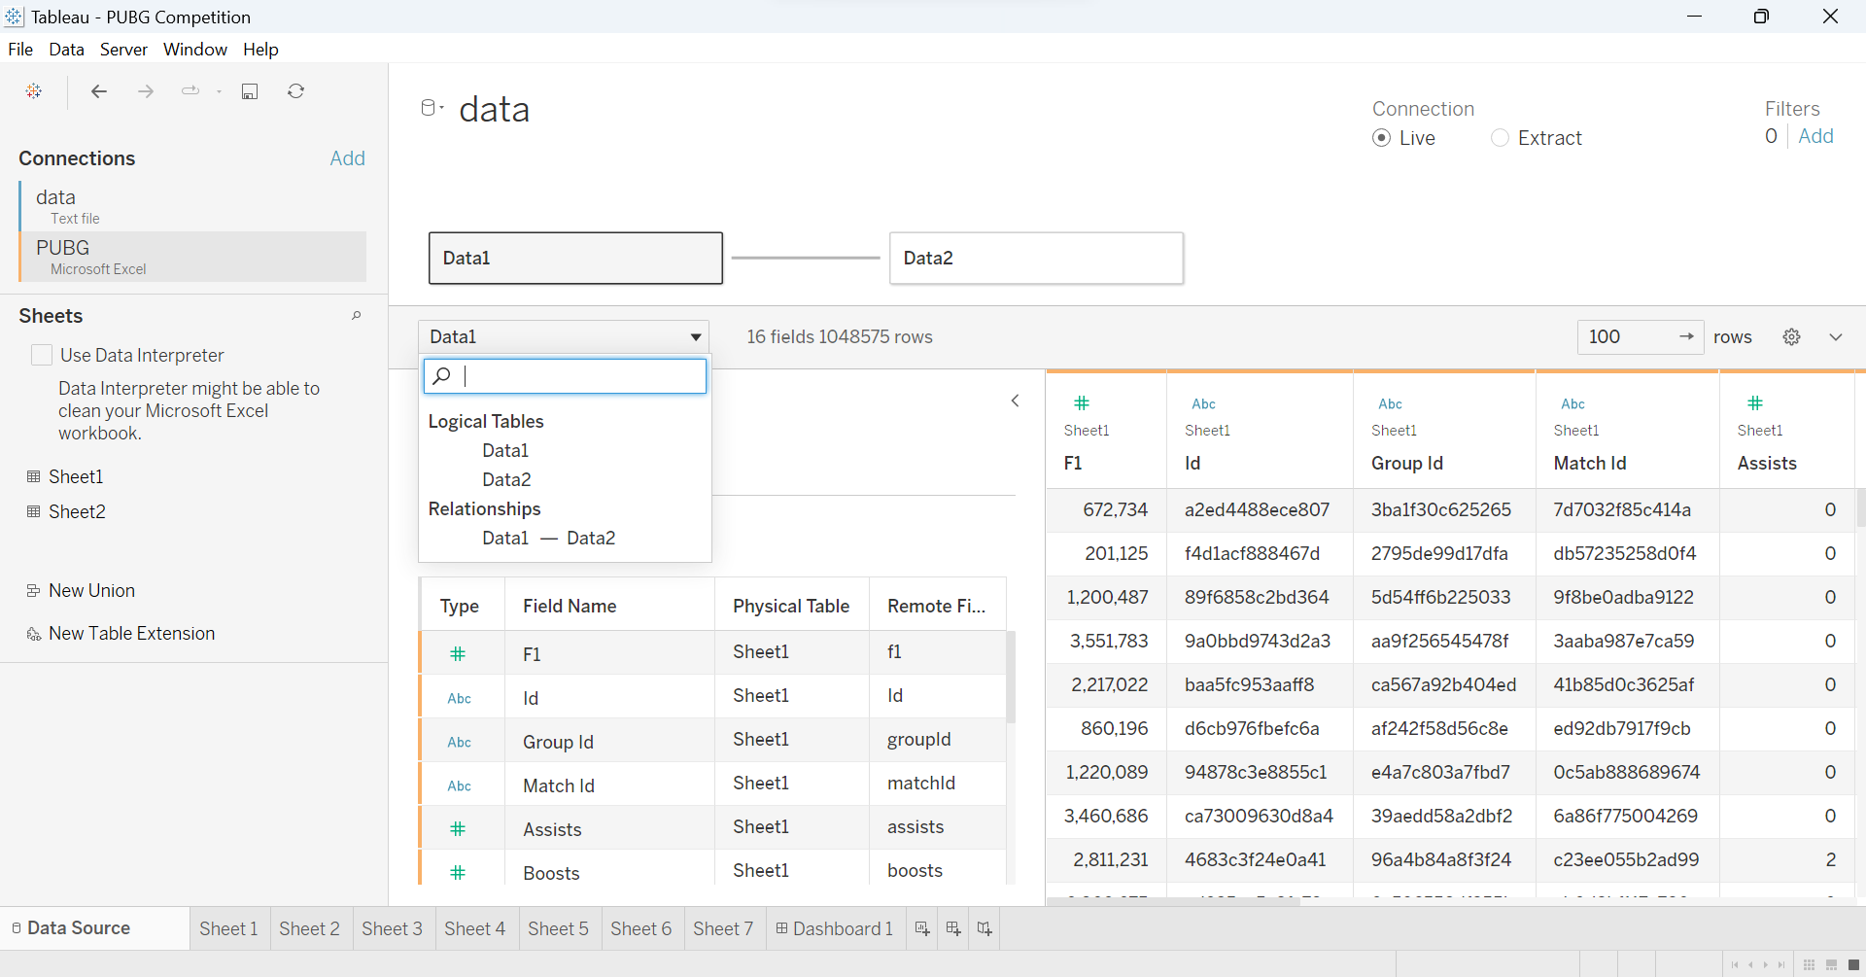

Figure 1: Importing Data set

(Source: Evaluated in Tableau)

The above image demonstrates importing of the dataset into the Tableau software. It is evident from the image that the "PUBG.csv" named file contains several attributes like F1, ID, Group ID, Match Id, and many others that are classified and sorted based on Data source order.

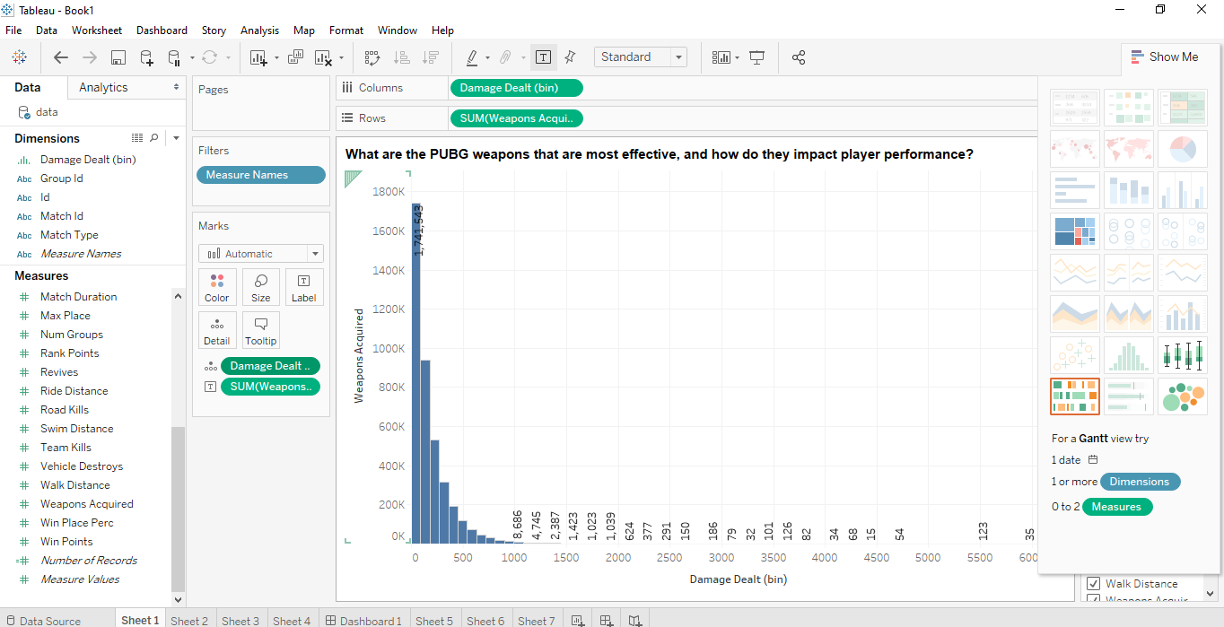

Figure 2: Visualization of the most effective PUBG weapons and how they impact player performance

(Source: Evaluated in Tableau)

The above image accounts for the visualization of the most effective PUBG weapons and the intensity by which it influences player performance. The aforesaid data is visualized with the help of a bar plot in which, the x-axis denotes the Damage Dealt (bin) and the y-axis denotes the Weapons acquired. It is evident from the image that for damage of 1000 the weapon acquired is 8686.

Figure 3: Visualization of game modes

(Source: Evaluated in Tableau)

The above image gives an account for the visualization of the different game modes that are most popular and effectively evaluate player performance. The data is visualized with the help of a bar plot the y-axis represents the total number of win points and the x-axis represents the gameplay modes. It is evident from the above image that the maximum win points are recorded for the “squadfpp”, having a total win point of 2,65,71,7714. The second to the list is the “duofpp” with a total win point of 1,39,25,4845. The “squad” gameplay comes at the third position with a value of 8,90,33,506 and the “win point” value is enumerated as 100M.

Figure 4: Visualization strategies do players utilize to win matches, and how do they differ depending on the game style or weapon selection

(Source: Evaluated in Tableau)

The above image provides a visual bar plot representation of the strategies majorly utilized by the players to secure the maximum number of wins. The x-axis accounts for the type of match played and the y-axis represents different components in different sections, like for win points ranging from 0M to 2M, the best strategy is "squad. fpp". The "squad. fpp" is evidence to be the best effective strategy concerning the sum of "rank points", "win place percentile, " weapons acquired" and many others. After that, "duo. fpp" is the best effective strategy as it renders the best values.

Figure 5: Relationship between player rank and factors like time survived, damage dealt, or kills

(Source: Evaluated in Tableau)

The above image effectively portrays the relationship between player rank and several factors like time survived, damage dealt, or kills. The above relationship is represented among “rank points” and “team kills”, “damage cell” and “match duration”. The relationship is effectively evaluated using a line plot for three instances. In the first instance, it is evident that the graph is plotted between rank points and team kills and represents that a maximum number of team kills records the optimum rank points. In the case of the second instance, the graph is plotted between “damage dealt” and “rank points” and enumerates that for the maximum damage taken, 4496 the rank point is 0. In the case of the third instance, the graph is plotted between “Match duration” and “rank points”, it becomes evident from the plot that for a match duration ranging from 1k to 2k there is a maximum number of rank points amounting to 6000.

Figure 6: “*Percentile winning placement*” based on several match types

(Source: Evaluated in Tableau)

The above image demonstrates the type of strategies that recorded the maximum percentile of wins. This data is represented with the help of bar plots. The x-axis represents the type of gameplay and the x-axis represents the “win place percentage”. It is evident from the graph that "squad. fpp" at a value of 1,92,441 records the maximum percentile of wins, Closer to 200k.The "duo. fpp" comes second in place with a value of 1,14,519 and a percentile win of 120k. The third place is recorded for squad game type with a value of 66,573 and a win percentile of more than 50k.

Figure 7: “*Damage Dealt*” based on several match types

(Source: Evaluated in Tableau)

The above figure represents the box plot visualization of the "match type" concerning the "Damage Dealt". It is evident from the figure that the "squad. fpp" gameplay type with a value of 5,53,41,794 posses the highest win points amounting to nearly 560k. After that, the "duo. fpp" with a value of 3,10,90,690 comes in second place with a number record value of near 310k. The squad comes at the third position with a value of 1,88,38,395 and the "number of record" values to nearly 200k.

Figure 7: “*Weapon selection*” based on several match types

(Source: Evaluated in Tableau)

The above image gives an account of the box plot representation of the “match type” and “weapon selection”. It is evident from the image that the “squad.fpp” gameplay type with a value of 1,500,007 records the highest number of weapons acquired with a value of more than 1500k. After that, the "duo. fpp" comes to second place with a value of 8,40,840 and records a weapon acquisition value of nearly 100k. This presentation effectively establishes the relationship between weapons acquired and the type of gameplay.

Figure 8: Final Dashboard consisting of all data visualizations

(Source: Evaluated in Tableau)

Figure 9: Final Dashboard consisting of all data visualizations

(Source: Evaluated in Tableau)

The above figure 8&9 gives an account of the dashboard creation; it contains an overview of all the visualizations that are performed to evaluate the PUBG gameplay tournament data. The aforesaid board is created to assist players in developing winning strategies and to help them in identifying their potential areas of improvement. The dashboard also helps to compare the results of the visualization in total and helps in better understanding of the relationships between the variables the most significant utility of this dashboard is that it enables the player to execute more informed data-driven judgments based on their gameplay-evaluated performance metrics.

# Conclusion

This section of the study accounts for all the concluding points of the study and gives an overview of all the tasks and visualizations performed in the execution of this study. The study report is divided into four sections. In the introduction, a general overview related to the background of the study is represented. After that, the methodology section discusses the source from which the data is acquired and the benefits that the source offers compared to other sources. The Analysis section comes next, which presents an in-depth discussion of all the visualizations performed to evaluate the PUBG gameplay tournament data. The gameplay data is evaluated based on certain questions, like What are the PUBG weapons that are most effective, and how do they impact player performance? Which game modes have the most influence on player performance, and which are the most popular? and many others. The visualizations are performed based on these questions which offer comparison and evaluation of the best effective weapon, the optimum strategies, and evaluation of the performance metrics of players. This study aims to assist PUBG players all over the world to improve their gameplay.

# 

# Bibliography

Altarriba-Bartes, A., Pena, J., Vicens-Bordas, J., Mila-Villaroel, R. and Calleja-Gonzalez, J., 2020. Post-competition recovery strategies in elite male soccer players. Effects on performance: a systematic review and meta-analysis. PLoS One, 15(10), p.e0240135.

Colomer, C.M., Pyne, D.B., Mooney, M., McKune, A. and Serpell, B.G., 2020. Performance analysis in rugby union: a critical systematic review. Sports Medicine-Open, 6, pp.1-15.

Koopmann, T., Faber, I., Baker, J. and Schorer, J., 2020. Assessing technical skills in talented youth athletes: a systematic review. Sports Medicine, 50, pp.1593-1611.

Mukherjee, S., Huang, Y., Neidhardt, J., Uzzi, B. and Contractor, N., 2019. Prior shared success predicts victory in team competitions. Nature human behavior, 3(1), pp.74-81.

Pappalardo, L., Cintia, P., Rossi, A., Massucco, E., Ferragina, P., Pedreschi, D. and Giannotti, F., 2019. A public data set of spatiotemporal match events in soccer competitions. Scientific data, 6(1), p.236.

# 